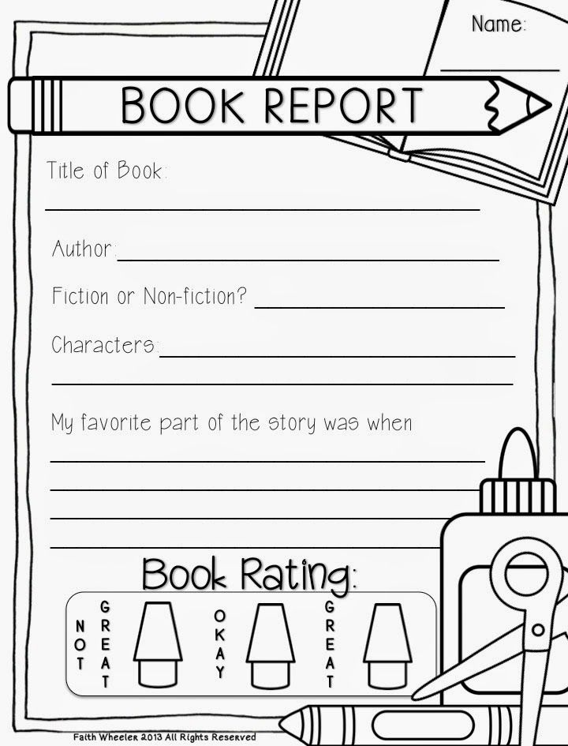
Number of Pages
Use the boxes below to tell the beginning, middle, and end of the story. Remember to use as many details as possible. Draw a picture for each section.
Beginning
_____________________________________________________________________________________________________________________________________________________________________________________________________________________________________________________________________________________________________________________________________________________________________________________________________________________________________________________________________________________________________________________________________________________________________
Middle
_____________________________________________________________________________________________________________________________________________________________________________________________________________________________________________________________________________________________________________________________________________________________________________________________________________________________________________________________________________________________________________________________________________________________________
End
_____________________________________________________________________________________________________________________________________________________________________________________________________________________________________________________________________________________________________________________________________________________________________________________________________________________________________________________________________________________________________________________________________________________________________

