National Parks Project
Our 3rd Grade class will be using the National Parks to learn more about the geography in the different regions of North America. These parks have been preserved because of their unique natural features. The focus of the project is to research the landforms, climate, vegetation, and animals that live in each park and how they reflect the geography in their region.
Each student will choose a park to research and present. Most of the work will be done in the classroom. However, if more time is needed, additional work at home might help.
Steps of the project:
1. Choose a park. Fill out the attached sheet and return it to school. Keep this page for your information.
2. Research and learn about the park using websites linked on Clever. Take notes on the paper provided. Use the notes to write the paragraphs on each slide.
3. Create a Google Slide presentation for the park on Google Classroom.
Slides must include 1 paragraph (minimum of 5 sentences) & 1 photo (maximum of 3) on the following topics:
    - Location and basic information (state and region, size, # of visitors)
    - Climate (weather throughout the year)
    - Landforms, Vegetation, & Animals (mountains, plants, rocks, and animals)
    - History (when it was created, any Native American tribes there before?)
    - Things to do and see
4. Present your project in front of the class. Try not to read you slides but instead present what you learned about each section.

Grade
Students will receive points based on the rubric. Students who put in minimal effort and information will be considered “Visitors”. Those who put in an average amount of effort and include a moderate amount of information will be considered a “National Park Enthusiast”. Those who go above and beyond in both their presentation and the information included will be considered a “National Park Ranger”. The Rubric is on the reverse side of this page.
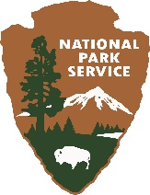
Plagiarism is not acceptable. We have been practicing using our own words in class and this is a great opportunity to talk with kids about it and encourage them to continue to restate information in their own way.
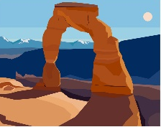
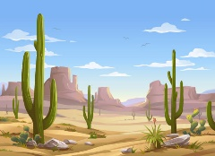
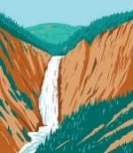
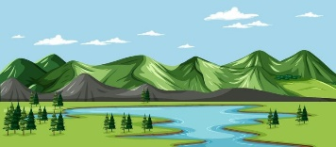
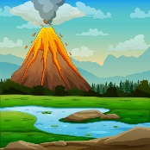

National Parks Project
Visitor Enthusiast Ranger
Possible points 20 points 25 points 30 points
Oral Presentation | Reads information and is only able to answer simple questions. | Shares information from memory and reading, if needed. Is able to answer most questions. | Shares information from memory in an excited tone. Expertly answers questions about the park. Keeps audience interested and engaged.
Written Information | Only a few pieces of basic information are provided. Park name, location, geography, and climate. | A moderate amount of detail is provided. The park name, location, date established, activities, and geography are listed. | A wealth of information is provided. The park name, location, date established and why (history), activities, geography, climate, natural resources and items of value in the park are present.
Overall appearance | Project appears unfinished and is missing important elements. Project does not contain a picture(s). | Project may be somewhat neatly done, but is missing one element. (i.e. park name, location, is sloppy or misspelled) Pictures of important places and/or activities may be included. | Project is complete and colorful in appearance with all elements included. Paragraphs are full and grammatically correct. Pictures of all important places and activities are included.

Please choose a park from the list below to research. Then fill out and return the form on the next page by Tuesday, October 10, 2023. Keep this page for your information. It’s ok if students choose the same park.

Acadia, ME-
Arches, UT-
Badlands, SD-
Bryce Canyon, UT-
Carlsbad Caverns, NM-
Crater Lake, OR-
Death Valley, CA-
Denali, AK-
Everglades, FL-
Glacier, MT-
Grand Canyon, AZ-
Grand Teton, WY-
Great Smoky Mountains, TN & NC-
Haleakala, HI-
Hawaii Volcanoes, HI-
Joshua Tree, CA-
Mammoth Cave, KY-
Mesa Verde, CO-
Mount Ranier, WA-
National Park of American Samoa-
Olympic, WA-
Redwood, CA-
Rocky Mountain, CO-
Shenandoah, VA-
Yellowstone, WY & MT & ID-
Yosemite, CA-
Virgin Islands-
Zion, UT-

National Parks Project

Name: _______________________________________________________________________
I have chosen to research ________________________________________________________
It is located in ______________________________ (state) and its state abbreviation is ______

Parent Signature: ______________________________________________________________
*Return only this page. Keep the first page for your information.
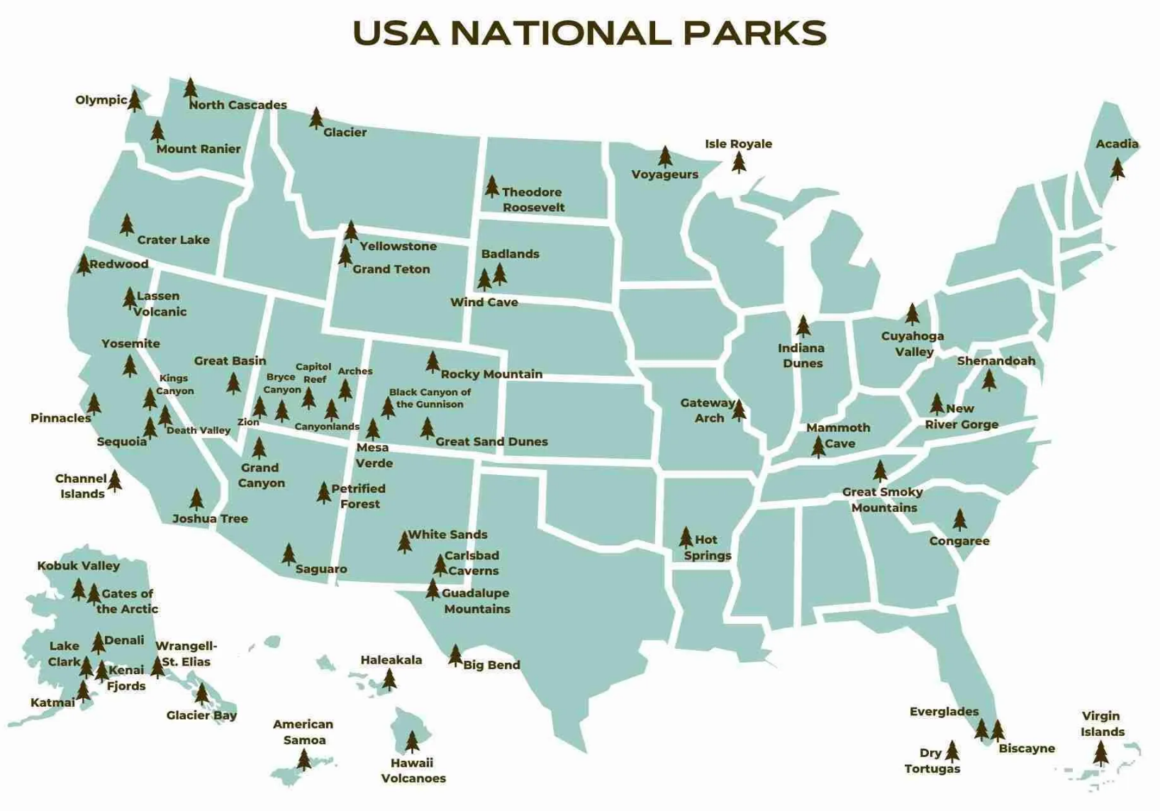
*Please note that not all of parks on this map are available to research. I have chosen the ones that most closely match what we learned in our Geography Unit. Please choose only from the list provided.

